AICT in Smart City Traffic System

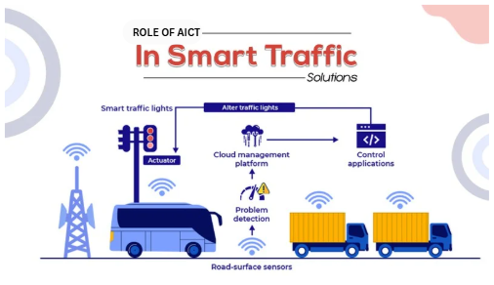

1. Objectives:
Analyzing the use of information and communication technologies (ICT) in a smart city traffic management system is the primary goal.
The goal of this research is to comprehend how importance of ICT tools—such as sensors, communication networks, and intelligent software—are applied to effectively manage traffic.
Reducing traffic and enhancing road safety is another goal of smart traffic systems.

2. Introduction and Problem Description
- A Traffic Control System refers to an advanced system that includes intelligent traffic lights, variable speed limits, and dynamic lanes to optimize traffic flow by using real-time data and dynamic adjustments based on traffic conditions.
- A Smart City Traffic Management System uses ICT to monitor traffic in real time and automatically control traffic signals based on actual road conditions. This intelligent approach helps overcome the limitations of conventional traffic systems.
- It Is a serious problem, The number of vehicles on city roads has gone up a lot. This has caused some big issues like traffic congestion longer travel times and more road accidents. We also have to deal with wasted fuel and environmental pollution from the vehicles on city roads. The vehicles, on city roads are making our air dirty.

3. Background and Context
- The idea of traffic systems comes from the idea of smart cities. In cities they use computers and technology to make public services better and people’s lives easier. This is what smart traffic systems are about making our lives better by using technology to improve the way traffic works. Smart traffic systems are based on the idea, as smart cities.
- The Internet of Things and Artificial Intelligence and other things, like cloud computing and wireless communication have really changed things. Now we can get traffic data in real time and look at it. This is because of the Internet of Things and Artificial Intelligence and these other technologies that are getting better all the time.
- Many cities around the world are implementing smart traffic solutions to manage increasing traffic demands and to create safer, cleaner, and more efficient transportation systems.
4. Soft and Tools Involved:
- Smart City Traffic Systems need a lot of software and hardware tools to work properly. These tools are really important for Smart City Traffic Systems to do their job. Smart City Traffic Systems use these tools every day to manage traffic and keep people safe.
Software:
- Traffic management software is really important because it helps us understand how traffic is moving and it controls the traffic signals. We use traffic management software to make sure traffic flows well. The signals work properly. Traffic management software is used to analyze the traffic flow and control the traffic signals.AI-based image processing software detects vehicles and congestion using camera feeds.
- Cloud platforms have a lot of traffic data that they store. This traffic data is used to analyze things and make decisions about the Cloud platforms. The Cloud platforms use this traffic data to understand what is going on and to make decisions, about the Cloud platforms.
- Mobile applications are really helpful because they give drivers and authorities updates on traffic at the time they need it. Mobile applications are very useful for people who want to know what the traffic is, like now.
Hardware / Tools:
- They have cameras and sensors at intersections to get information about the traffic. The cameras and sensors are there to collect traffic data so they can see what is going on. This traffic data, from the cameras and sensors is really useful.
- These little computers, like Arduino, Raspberry Pi or PLCs do the work of processing the data right where they are. They are called embedded systems. They handle the data locally on the Arduino, Raspberry Pi or PLCs themselves.
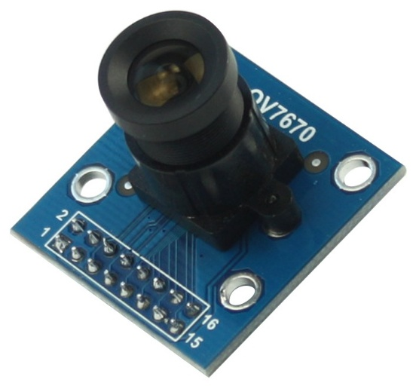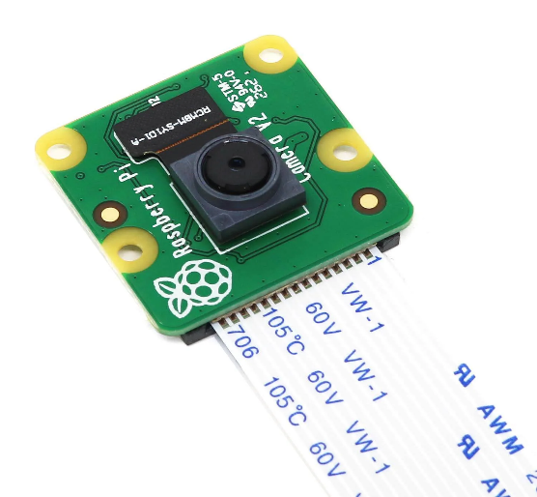
Arduino Camera Raspberry Pi
- Communication modules like Wi-Fi, 4G/5G, and fiber optics transmit data to control centers.
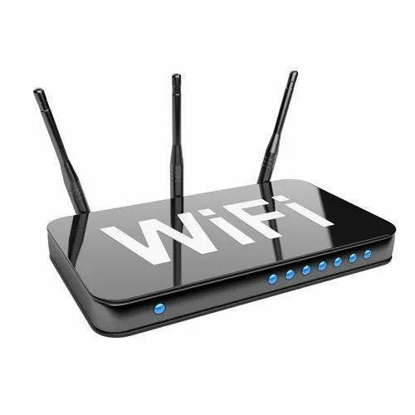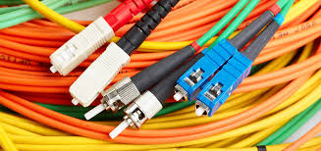
Wi-Fi Fiber Optics

5. Methodology and ICT Components
Methodology:
Input Data:
- First, traffic data is collected using sensors and cameras installed on roads. Like speed of car, air pollution etc.
Processing:
- This data is processed using embedded systems and intelligent algorithms to calculate vehicle density and traffic flow.
Transfer Data:
- The processed information is transmitted through communication networks to a central traffic control system.
Output:
- Based on real-time analysis, traffic signals are adjusted automatically to optimize traffic movement and control traffic signals.
Alerts are generated in case of accidents or emergency situations.
ICT Components:
Sensors and Cameras:
- These Sensors and Cameras collect real-time traffic information so we can see what is happening on the road now with the help of these Sensors and Cameras.
Embedded Systems:
- Process data and control traffic signals
Communication Networks:
- These networks allow data to be sent between devices in the field and the control centers. This means that the devices in the field can share information, with the control centers and the control centers can send instructions to the devices.
Cloud Computing:
- This is where we store and look at traffic data. Cloud Computing can handle a lot of data without any problems. We use Cloud Computing to store traffic data for future use.
User Interfaces:
- Dashboards and mobile apps for monitoring and control

6. Applications and Relevance
Applications
- We use traffic systems for a lot of things. They help control traffic signals in a way. Smart traffic systems can also detect accidents. Give priority to emergency vehicles They provide traffic updates to drivers in real time. They make our lives easier, by helping us navigate through traffic. Smart traffic systems are very helpful when it comes to giving us real-time traffic updates.
Engineering and Societal Relevance
- From an engineering perspective, when we look at these systems from an engineering point of view, we see that they bring together hardware and software and communication technologies.
- From a societal perspective, smart traffic systems reduce congestion, save fuel and time, lower pollution levels, improve road safety, and enhance the overall quality of urban life.

7. Discussion
- The Smart City Traffic Management System is really good at using technology to fix problems with traffic in cities. The Smart City Traffic Management System shows us that we can use computers and things, like that to make transportation in cities. The Smart City Traffic Management System can help people who live in cities.
- The real-time data collection and intelligent decision-making make traffic control more efficient and reliable. We can use real-time data collection to make traffic control work smoothly and intelligent decision-making to handle any problems that come up. This way traffic control is more efficient and reliable.
- Some challenges are face to make smart city traffic system like high installation cost, maintenance cost, cloud computing. Despite all these challenges, investing in them is a valuable investment for a smart city traffic system
8. Conclusion
- In conclusion, the Smart City Traffic Management System is a significant application of Information and Communication Technologies.
By integrating sensors, communication networks, and intelligent software, these systems improve traffic flow, enhance safety, and reduce environmental impact.
Smart traffic systems play a vital role in building sustainable and efficient smart cities.

9. Learning Outcomes
After completing this case study, the following learning outcomes were achieved:
- Understanding of real-world ICT applications
- Knowledge of smart city and traffic management technologies
- Insight into integration of engineering systems and ICT
- Awareness of societal benefits of intelligent systems

Section: A
Registration No: 2025-MC-167
2025-MC-199
2025-MC-227
2025-MC-241

